**DBMS LAB**

**ASSIGNMENT-5**

**SNEHA SINGH**

**20198023**

**IT 5 B2**

**Q.1. Write the SQL queries for the following with respect to database created:**

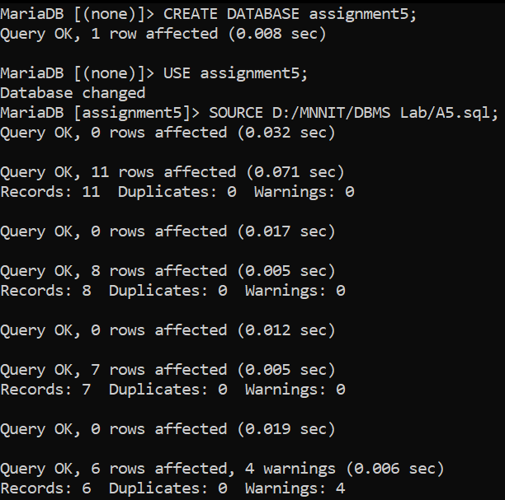

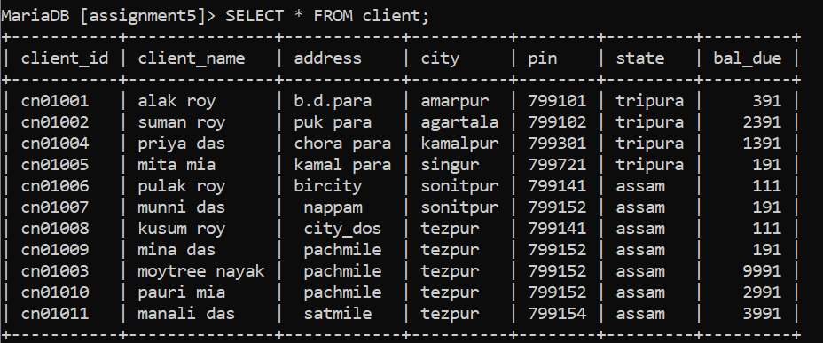

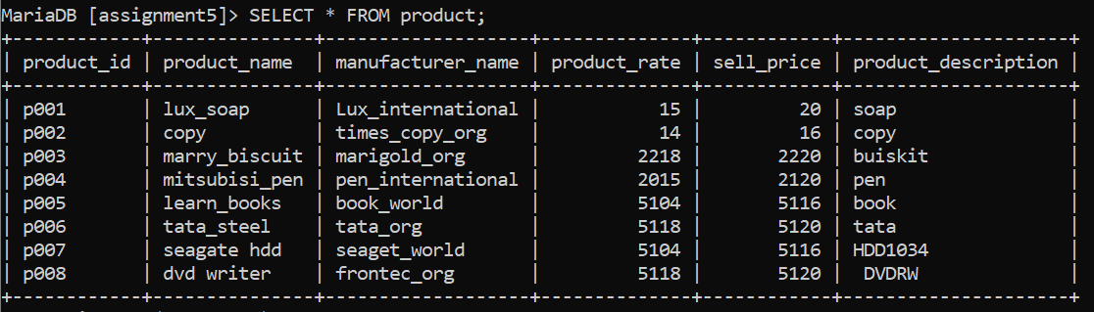

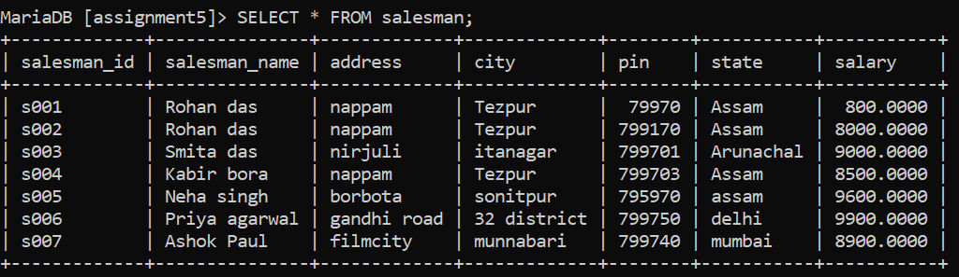

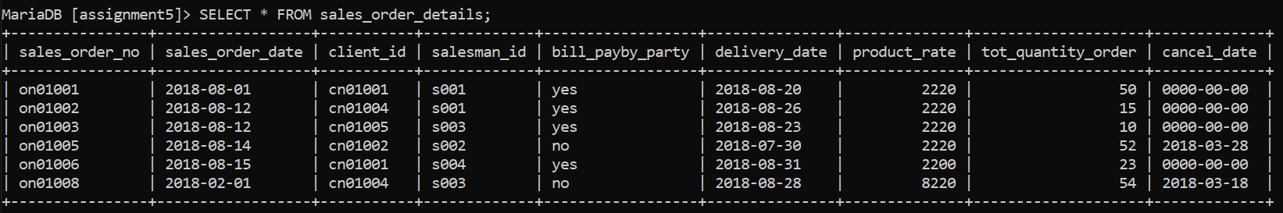

**(a) Retrieve the list of names and the cities of all the clients.**

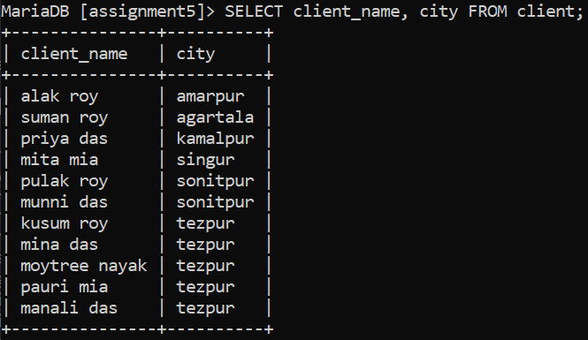

**(b) List the various products available.**

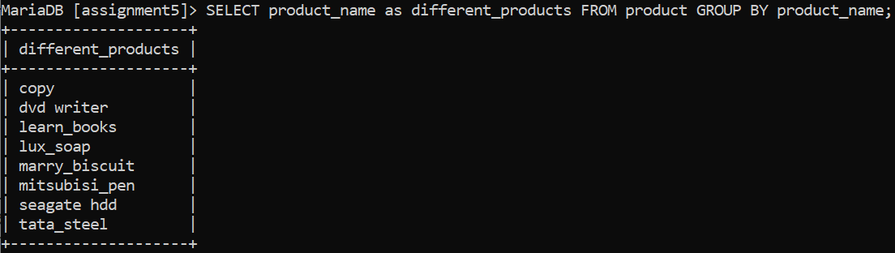

**(c) Find the names of all clients having ‘a’ as the second letter in their names.**

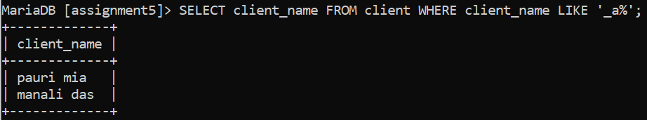

**(d) List all the clients who are located in Allahabad.**



**(e) Find the products whose selling price is greater than 2000 and less than or equal to 5000.**

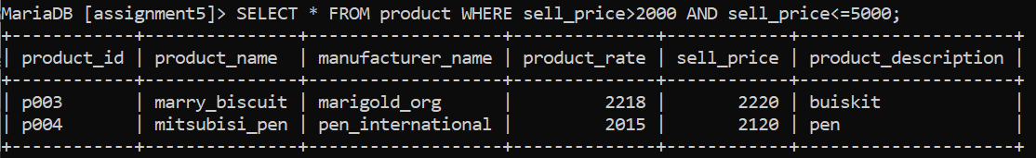

**(f) Add a new column NEW_PRICE into the product table.**

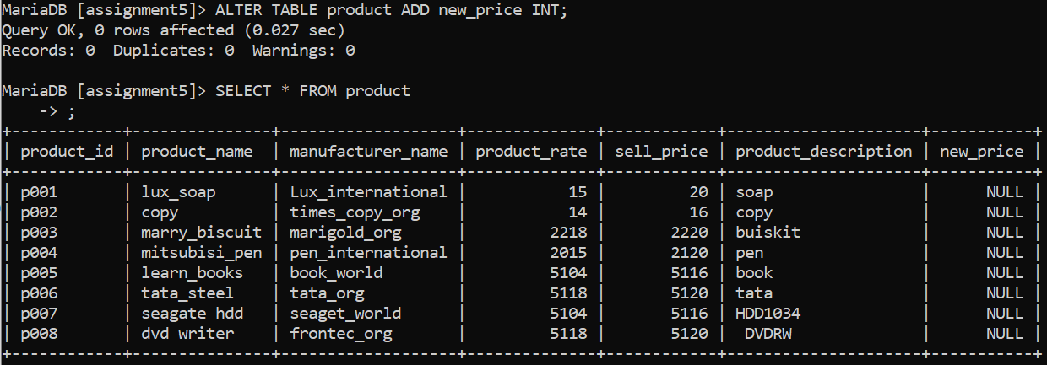

**(g) Rename the column P_rate of Sales_Order_Details to new_P_rate.**

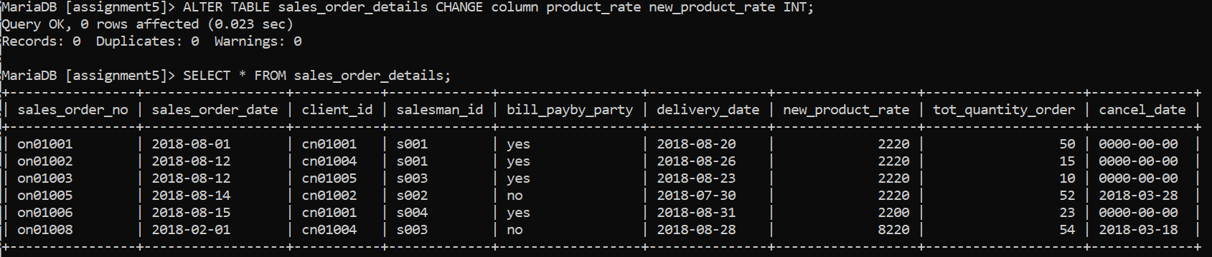

**(h) List the products in sorted order of their description.**

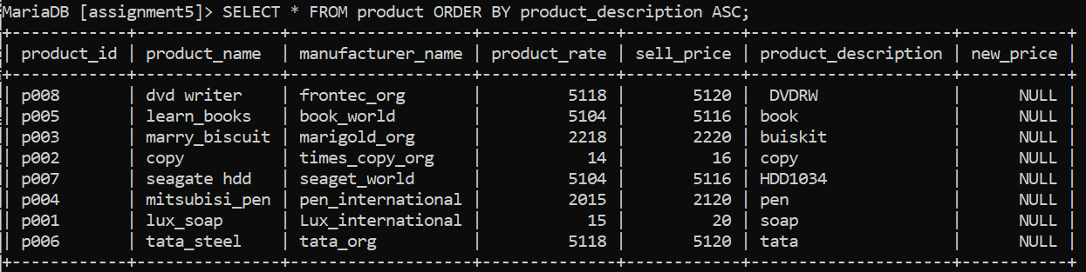

**(i) Display the order number and date on which the clients placed their order.**

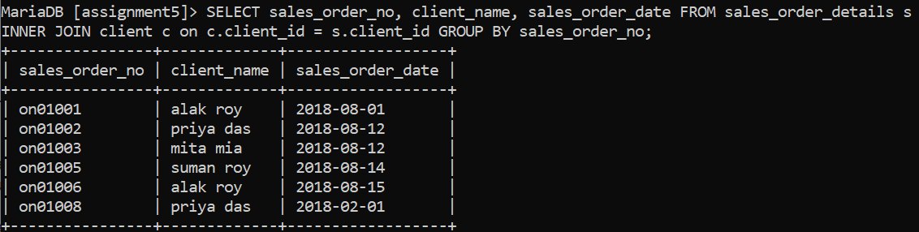

**(j) Delete all the records having delivery date before 25th August, 2018.**

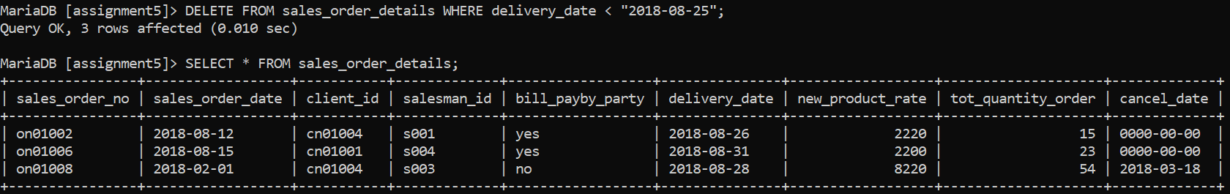

**(k) Change the delivery date of order number ON01008 to 16-08-18**

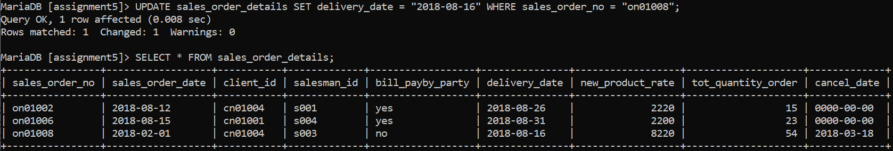

**(l) Change the bal_due of client_no C01003 to 1200**

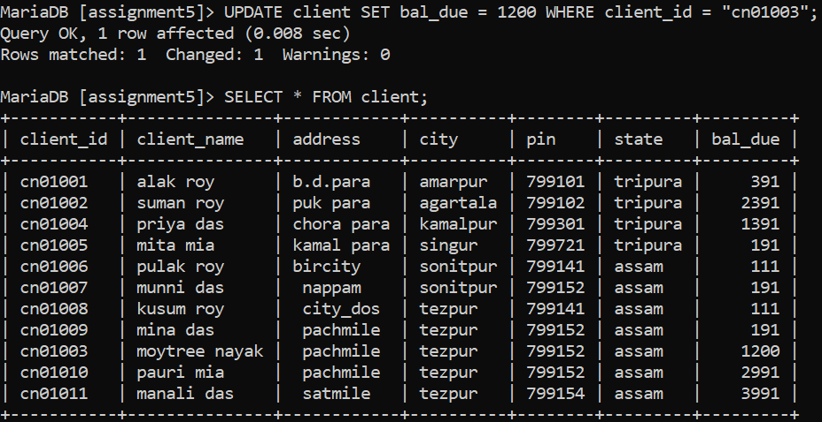

**(m)Find the product with description as ‘HDD1034’ and ‘DVDRW’**

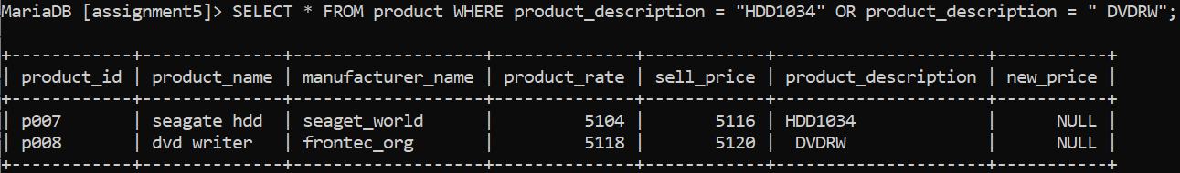

**(n) List the names, city and state of the clients not in the state of ‘ASSAM’**

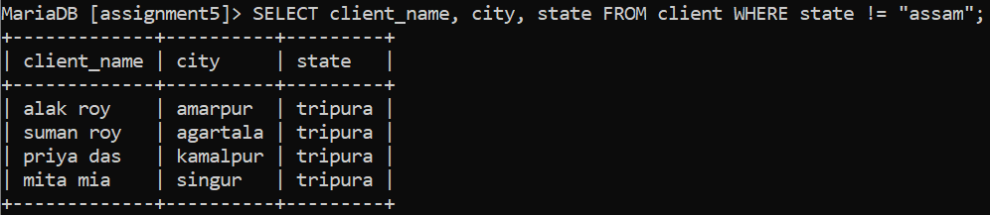

**(o) List of all orders that were cancelled in the month of March.**

